THREE INVESTIGATIONS.
1(a) Find the coordinates of the points where the line y = ½x crosses the
circle given by (x – 4)² + y² = 8

Subs y = ½x into (x – 4)² + y² = 8 and we get (x – 4)² + x² = 8
4
x² – 8x + 16 + x² = 8
4
4x² – 32x + 64 + x² = 32
5x² – 32x + 32 = 0
x = 1.24 and 5.16
intersection points are (1.24, 0.62) and (5.16, 2.58)

(b)

A line of the form y = mx can cross the circle (x – 4)² + y² = 8
once or twice or not at all.
Find the value of m so that the line is a tangent.
Subs y = mx into (x – 4)² + y² = 8 and we get (x – 4)² + m²x² = 8
x² – 8x + 16 + m²x² = 8

(1 + m²) x² – 8x + 8 = 0
This equation will only have 1 solution so the discriminant = 0
= 64 – 4×(1 + m²)×8 = 0
64 – 32 – 32m² = 0
32 = 32 m²
m² = 1
so m could be 1 or – 1
There are 2 possible tangents y = x and y = –x

2(a)
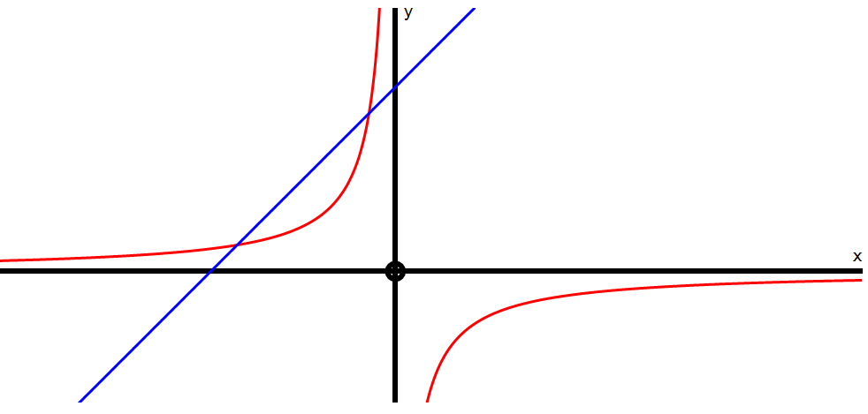

The graphs above show the intersection points of y = – 6 and y= x + 5
x
Find the coordinates of the intersection points algebraically.
x + 5 = –6
x
x² + 5x = – 6
x² + 5x + 6 = 0
(x + 2)(x + 3) = 0
x = –2 and –3 The intersection points are (–2, 3) and (–3, 2)
(b) Consider the line y = mx + 5 which has a fixed y intercept at P but a
variable gradient m.
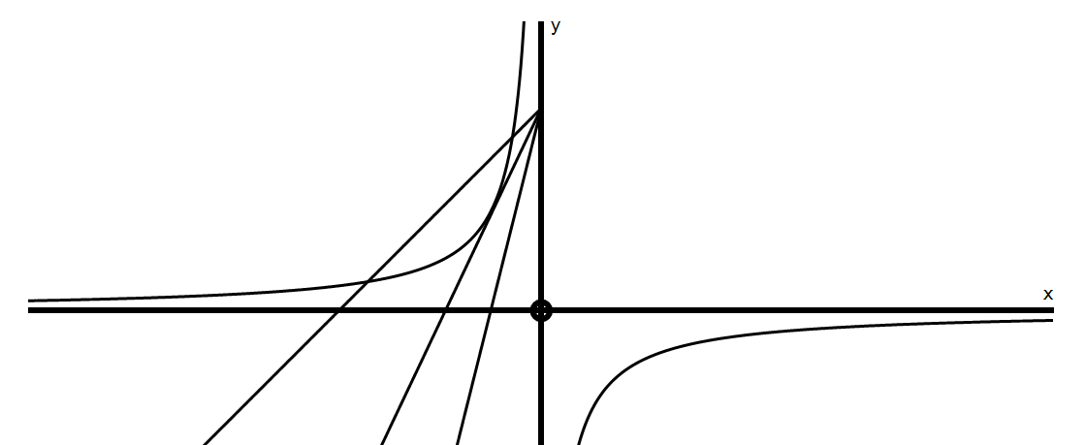
P
A B C
Line A crosses the hyperbola twice, Line B is a tangent and Line C does not cross.
Find the value of m so that y = mx + 5 is a tangent.
mx + 5 = – 6
x
mx² + 5x + 6 = 0
to be a tangent = 0 so 25 – 24m = 0 giving m = 25
24
(c) Write down the range of values for m so that there will be 2 intersections.
> 0 so 25 – 24m > 0 giving 25 > 24m so 25 > m
24
(d) Write down the range of values for m so that there will be no intersections.
< 0 so 25 – 24m < 0 giving 25 < 24m so 25 < m
24

3(a) The graphs below show y = (x – 3)² and y = x – 3
Calculate algebraically the intersection points.
x² – 6x + 9 = x – 3
x² – 7x + 12 = 0
(x – 3)(x – 4)=0
So x = 3 and x = 4
The intersection points are:
(3, 0) and (4, 1)

(b) Consider the line y = mx – 7 which has a fixed y intercept but a variable
gradient m.
Find the value of m so that
y = mx – 7 is a tangent to the parabola y = (x – 3)²
x² – 6x + 9 = mx – 7
x² – (m + 6)x + 16 = 0
to be a tangent = 0
so (m + 6)² – 64 = 0
(m + 6) = 64
m + 6 = ± 8

hence m = 2 or m = – 14
P

This means there are 2 tangents from P above.
The tangents are y = 2x – 7 and y = –14x – 7

P

(c) If y = mx – k is to be a tangent to y = (x – k)² show that m² + 4km – 4k = 0
x² – 2kx + k² = mx – k
x² – (2k + m)x + (k² + k) = 0
For the line to be a tangent, this equation must have 1 solution so its discriminant = 0
= (2k + m)² – 4(k² + k) = 0
4k² + 4km + m² – 4k² – 4k = 0
So m² + 4km – 4k = 0

