The Norfolk Pine Tree.
F
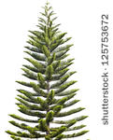

y

A B C D E x

The large Norfolk pine tree is 30 metres from the side of the hemispherical dome-house. AB = 30 m
The diameter of the dome-house is 16 metres.
The tree has grown so much in the last year that it is now just visible from the point E which is on the other side of the dome-house.
The distance DE is not known but the gradient of the “line of sight” from E to the top of the tree F, is – ½ .
Calculate the height of the Norfolk pine tree.

