Towards Excellence.
1.
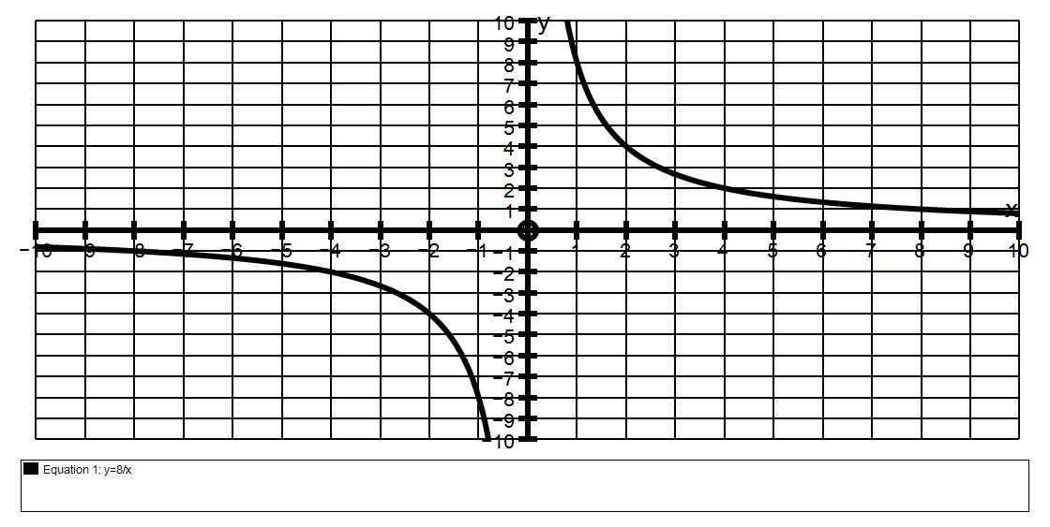
(a) Find algebraically, the intersection points of the graphs y = 8 and y = -x + 6
x
8 = -x + 6
x
8 = - x² + 6x
x² – 6x + 8 = 0
(x – 2)(x – 4) = 0
x = 2 and x = 4
y = 4 and y = 2
intersection points are (2, 4) and (4, 2)

(b)(i) If y = -x + c is to be a tangent to y = 8 find c
x
8 = -x + c
x
8 = - x² + cx
x² – cx + 8 = 0
if there is to be 1 solution
then the discriminant = 0
so c² – 4 × 8 = 0
c² = 32
c ≈ ± 5.66

(ii) Explain fully why there are two values for c.
A line with a gradient of 2 can be a tangent to each half of the hyperbola.
See diagram above.
(c) Find all the values of c for which the line y = -x + c will cross the
Hyperbola y = 8 at exactly two points.
x
Line will cross twice if there are 2 solutions to x² – cx + 8 = 0 and this occurs if the discriminant is positive so c² – 4 × 8 > 0
c² > 32
so c < – 5.66 or c > +5.66
(d) Find all the values of c for which the line y = -x + c will NOT cross the
Hyperbola y = 8 at all.
x
Line will not cross if there are no solutions to x² – cx + 8 = 0 and this occurs if the discriminant is negative so c² < 32
so - 5.66 < c < +5.66
2. The graph shown has the equation y = 6 + 6
x
If a line y = mx is to be a tangent to y = 6 + 6 find m.
x
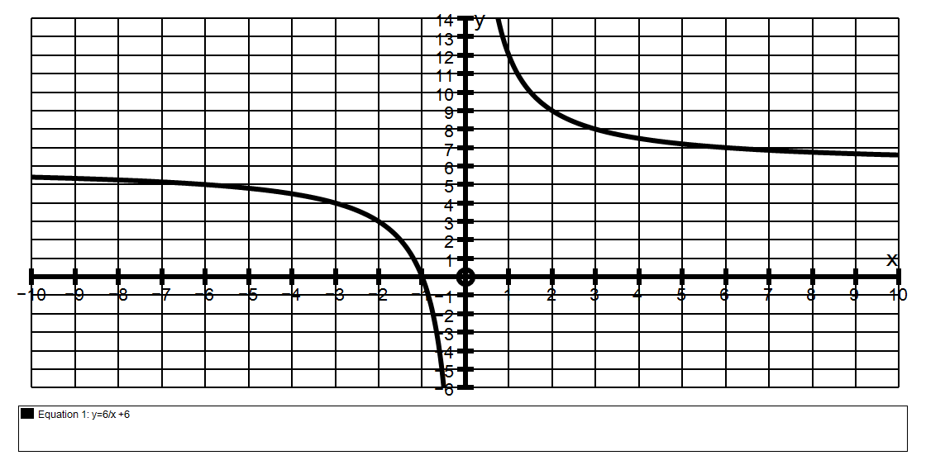
mx = 6 + 6
x

mx² = 6 + 6x

mx² – 6x – 6 = 0

there will be only 1 solution if = 0
so 36 – 4m(-6) = 0
24m = - 36
m = - 3
2

3. The graph below has the equation y = -12 + 9
x
If a tangent has a gradient of 2, find the coordinates of the point where the tangent meets the x axis.
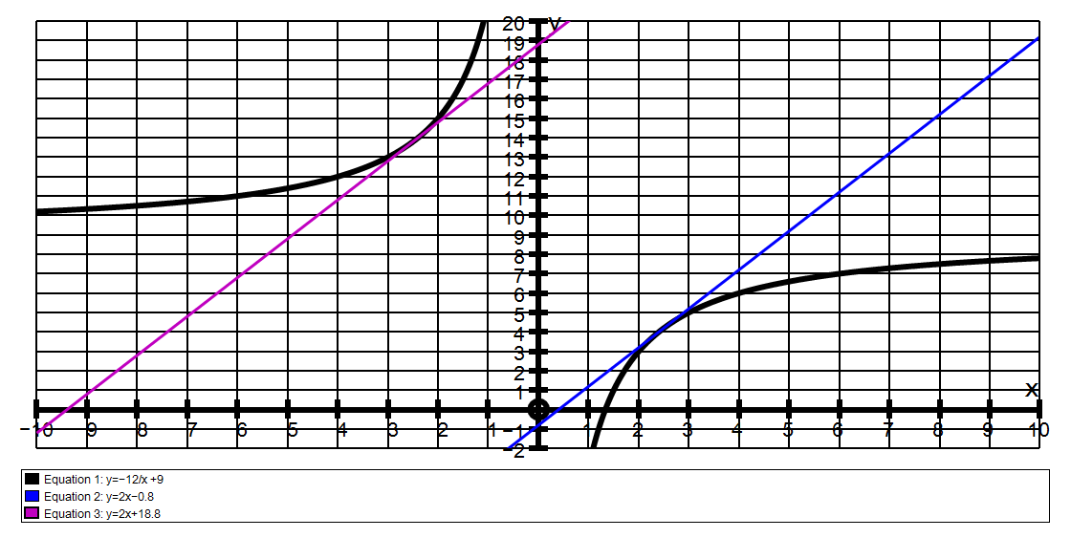
Let tan be y = 2x + c
Intersection is found by solving:
2x + c = -12 + 9
x
2x² + cx = -12 + 9x

2x² + x(c – 9) + 12 = 0
Only 1 sol if = 0
(c – 9)² - 4×2×12 = 0
(c – 9)² = 96
c = 9 ± 9.8
c = -0.8 or 18.8

Explain clearly why there are TWO answers!
There are two tangents because if the gradient of a line is 2 it can be a tangent to each half of the hyperbola as shown on the diagram.
The 2 equations are y = 2x – 0.8 and y = 2x + 18.8
These cross the x axis when the y value is 0 ie at x = 0.4 and x = -9.4

