THE TILE- CUTTER’S PROBLEM.

A Tile-Cutter wants to prepare square tiles in his workshop so that they can be transported to various jobs and can be laid much more quickly.
The most popular pattern he likes to use is as shown below:

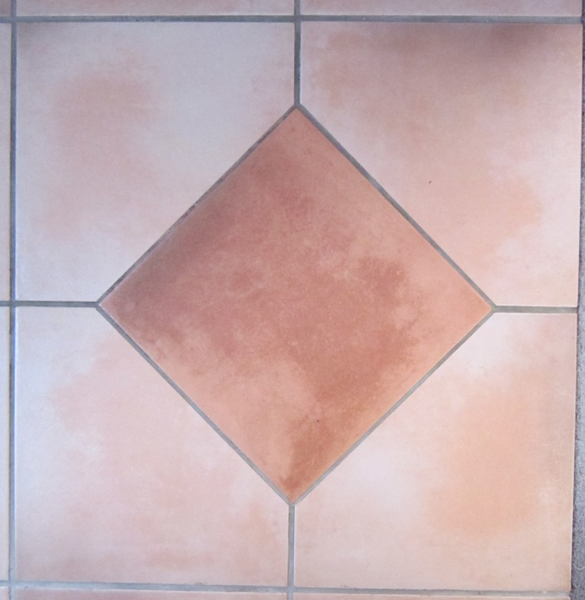
x
The pattern clearly consists of 5 square tiles.
Because he has square tiles of several different sizes he want to work out a formula for the distance x in terms of the length of the side of the tile d as shown on the diagram.

This will make the pre-cutting of the various sizes of tiles more economical.

Find x in terms of d.

d

THE TILE- CUTTER’S PROBLEM. SOLUTION
A Tile-Cutter wants to prepare square tiles in his workshop so that they can be transported to various jobs and can be laid much more quickly.
The most popular pattern he likes to use is as shown below:
A
B
x
The pattern clearly consists of 5 square tiles.
Because he has square tiles of several different sizes he want to work out a formula for the distance x in terms of the length of the side of the tile d as shown on the diagram.

This will make the pre-cutting of the various sizes of tiles more economical.

Find x in terms of d.

d
The key is to draw the diagonals of the central square as above.

d d If the diagonal is p then by Pythagoras’
Theorem we get p² = d² +d²
p p² = 2d²
p = d√2
The distance AB = d√2
2

so that x = d – AB
x = d – d√2
2
The required formula is x = d ( 1 – √2)
2
Or perhaps more simply x = 0.293d
For his 10cm tiles x = 2.93 cm
For his 15 cm tiles x = 4.39 cm
For his 20 cm tiles x = 5.86 cm
For his 30 cm tiles x = 8.79 cm (as on the picture)

