Find the equation and Domain and Range for each graph below:
(label each graph clearly!)

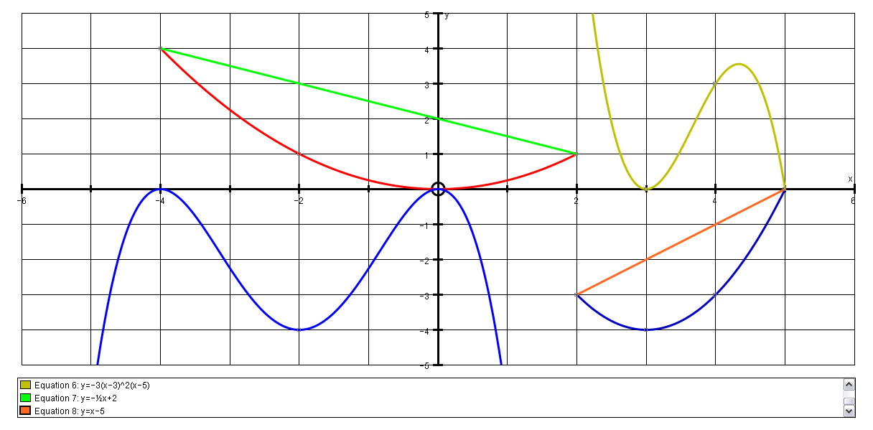
F
E
D
C
B
A
A  y = - bx² (x + 4)²  sub x = -2, y = -4  -4 = -b. 4 . 4  b = ¼  y = - x² (x + 4)²  4  Domain =All x values  Range = All y values | C  y = - ½ x + 2  D is -4 ≤ x ≤ 2  R is 1 ≤ y ≤ 4 | E  y = x – 5  D is 2 < x < 5  R is -3 ≤ y ≤ 0
B  y = bx²  sub x = 2, y = 1  1 = b.4  b = ¼  y = x²  4  D is -4 < x < 2  R is 0 ≤ y ≤ 4 | D  y = -b(x – 3)²(x – 5)  sub x = 4, y = 3  3 = -b(-1)  b = 3  y = -3(x – 3)²(x – 5)  D is -∞ < x < 5  R is 0 ≤ y < ∞ | F  y = (x – 3)² – 4  D is 2 < x < 5  R is -4 ≤ y ≤ 0

