**FINDING EQUATIONS OF GRAPHS.**

Hints:

(a) See where graph crosses *x* axis. eg at 2 and 4 so basis is *y =****a*** *(x – 2)(x – 4)*

(b) See where graph crosses *y* axis to work out the value of ***a***

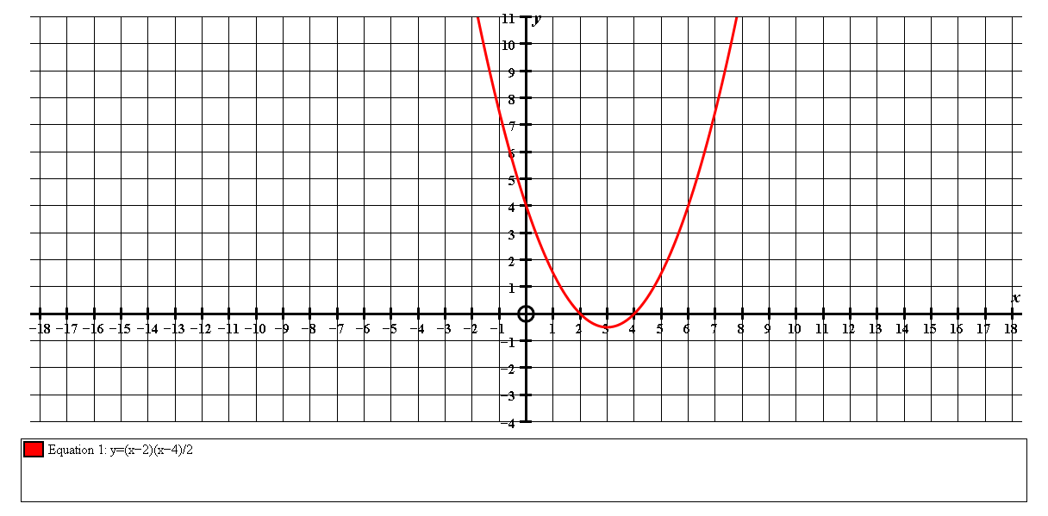

Crosses *x* axis at 2 and 4 so equ is of the form *y =****a*** *(x – 2)(x – 4).* Crosses *y* axis at 4 so subs *x = 0, y = 4* to find the constant ***a***.

*4 = a ( 0 – 2 )(0 – 4)*

*4 = 8a*

*a* = ½

Equation is *y =*½ *(x – 2)(x – 4)*

*OR y = (x – 2)(x – 4)*

*2*

______________________________________________________________

Find the equations of the following curves:

1.   
 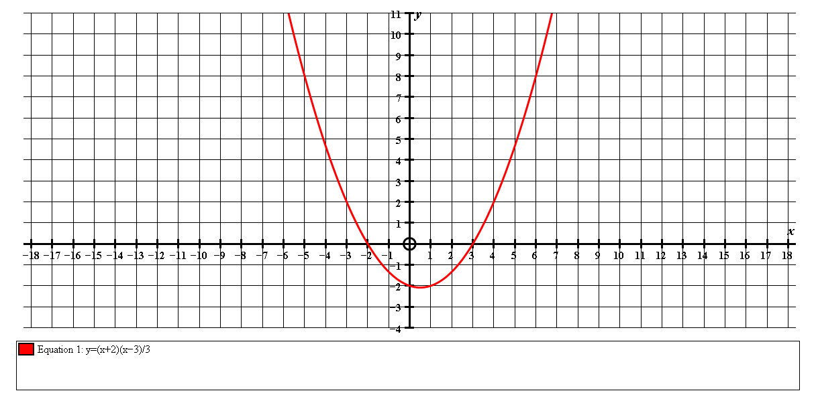

***y = (x + 2)(x – 3)***

***3***

2.

N.B. when parabola goes through

the point (0, 0) use another point

such as the max point (3, 3)

***y = – x (x – 6)***

***3***

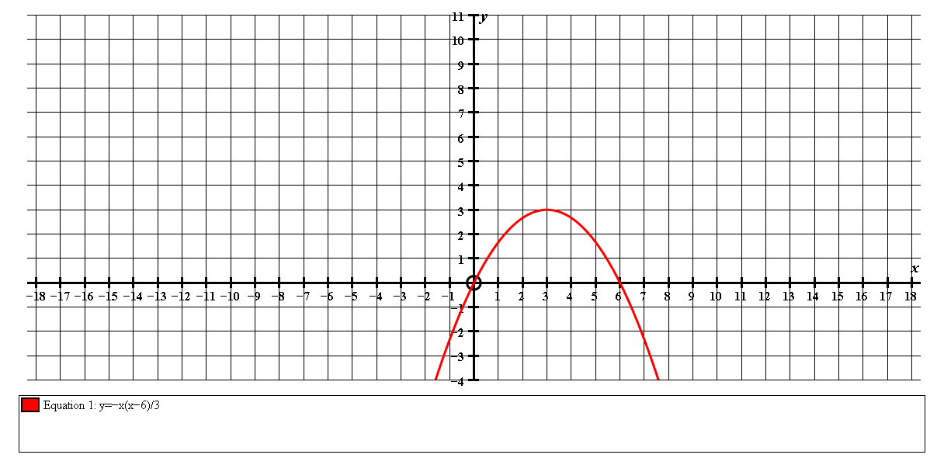

3.

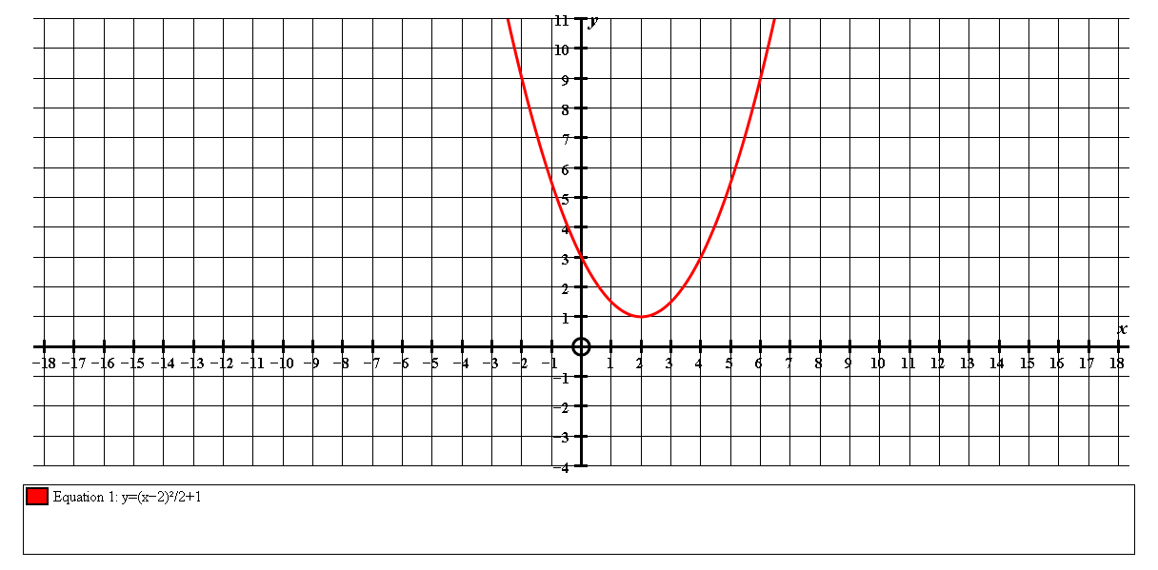

N.B. when parabola does not cross the *x* axis it is of the form ***y = a(x – b)2 + c***

From the graph, ***b*** and **c** should be obvious.

Work out c using (0, 3).

***y = (x – 2)2 + 1***

***2***

4.

Equ will be of the form :

***y = p x(x – a)(x – b)***

***a and b*** *should be obvious.*

To find ***p*** you need to subs a point such as (2,1) or min (6, -3)

***y = x(x – 3)(x – 8)***

***12***

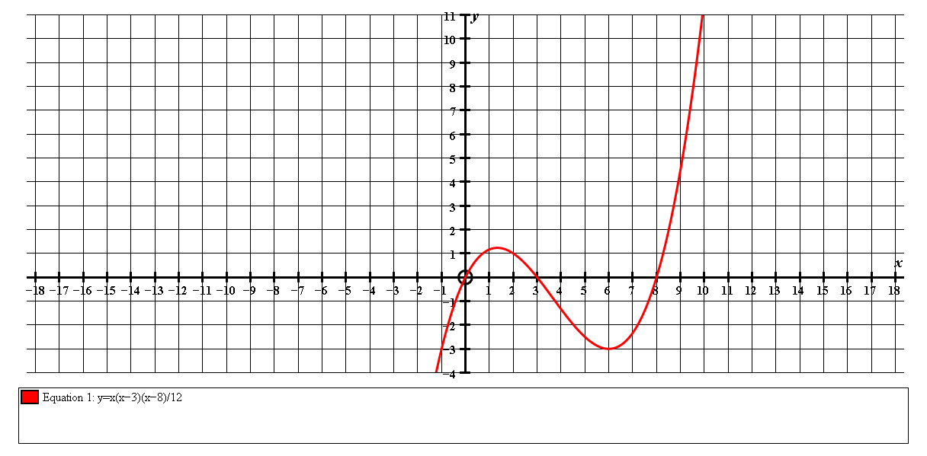

5.

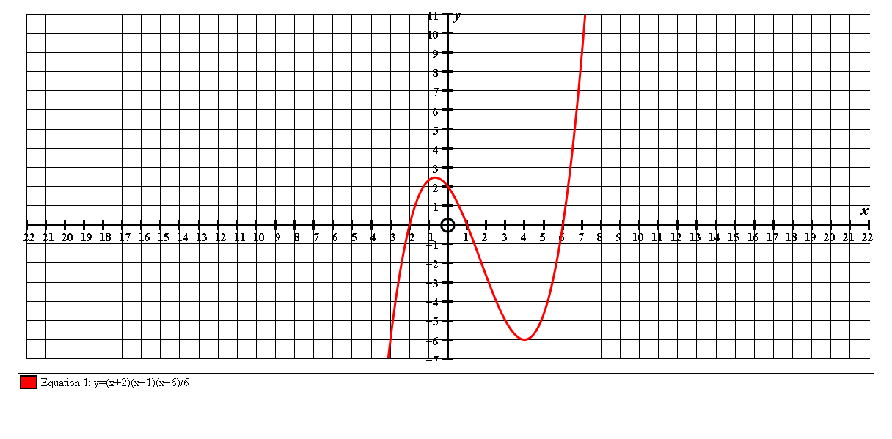

***y = (x + 2)(x – 1)(x – 6)***

***6***

6.

Equ will be of the form :

***y =p x(x – a)2***

***a*** *should be obvious.*

To find ***p*** you need to subs a point such as (2,2) or max (1, 4)

***y = x(x – 3)2***

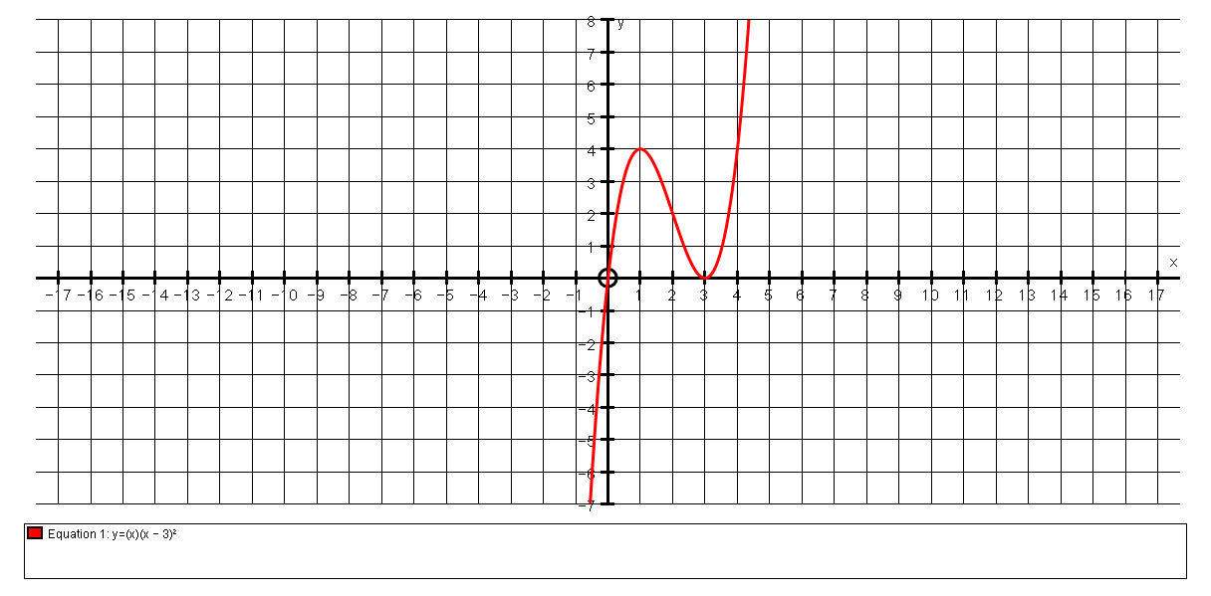

7.

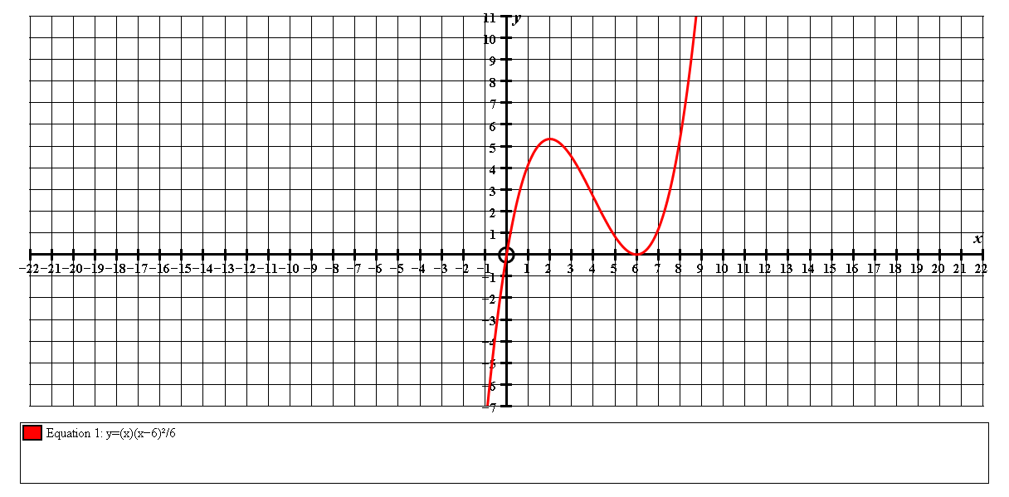

Equ will be of the form :

***y =p x(x – a)2***

***a*** *should be obvious.*

To find ***p*** you need to subs a point such as (1, 4)

***y = 4x(x – 6)2***

***25***

8.

Equ will be of the form :

***y =p x2(x – a)2***

***a*** *should be obvious.*

To find ***p*** you need to subs a point such as max (2, 4)

***y = x2 (x – 4)2***

***4***

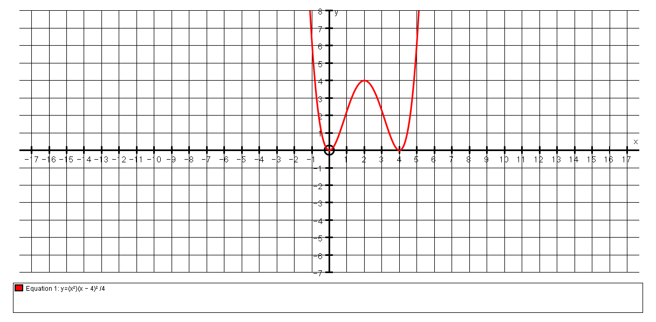

9.

Equ will be of the form :

***y =p (x + a)(x + b)(x – c)(x – d)***

***a, b, c and d*** *should be obvious.*

To find ***p*** you need to subs a point such as (0, 3) or (2, -6)

N.B. Sometimes the graph **seems** to go through points such as (3, -1) but it does not.

***y = (x + 2)(x + 1)(x – 1)(x – 3)***

***2***

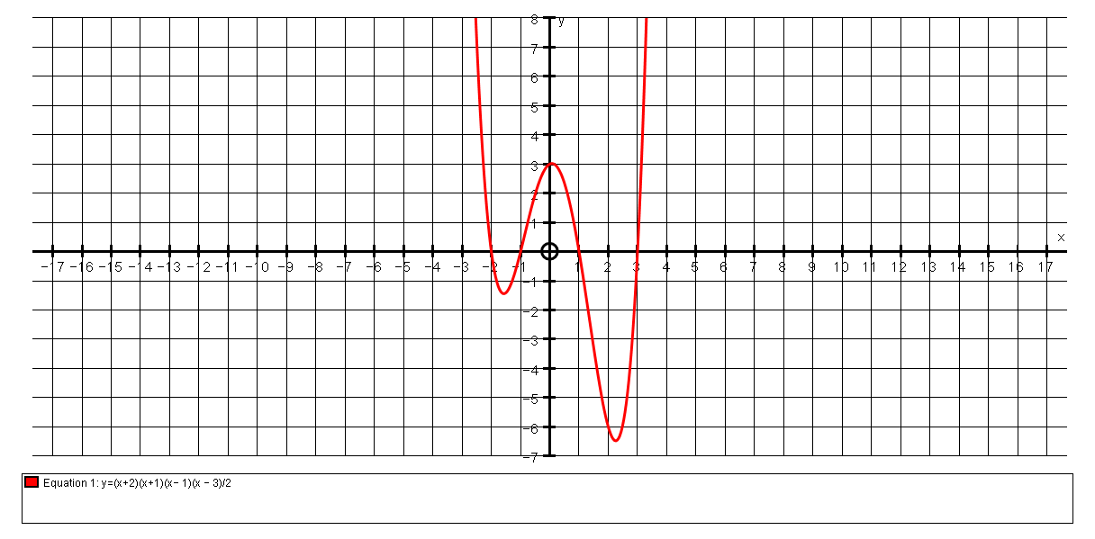

11.

Equ will be of the form :

***y =p(x + a)2(x – b)2***

***a and b*** *should be obvious.*

To find ***p*** you need to subs a point such as max (0, 4)

***y = (x + 4)2 (x – 4)2***

***64***

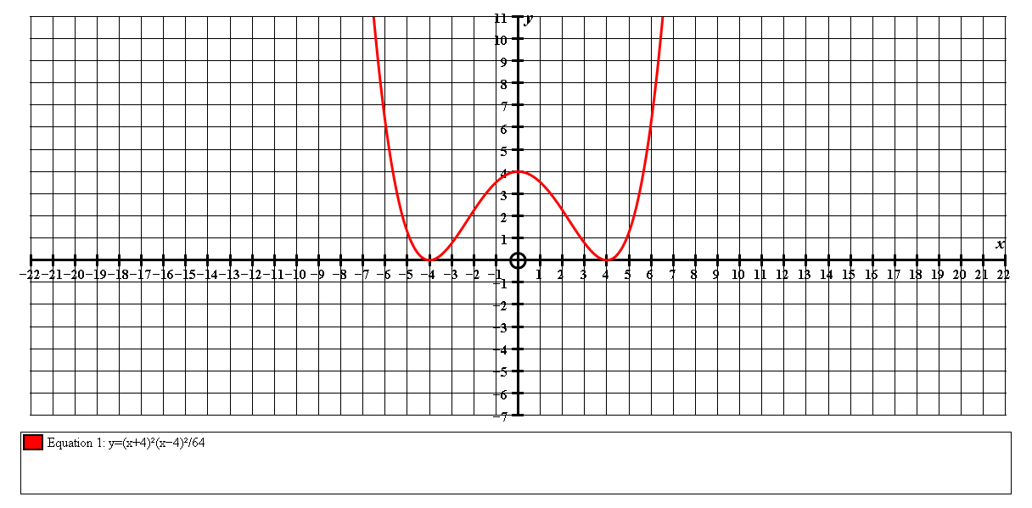

12.

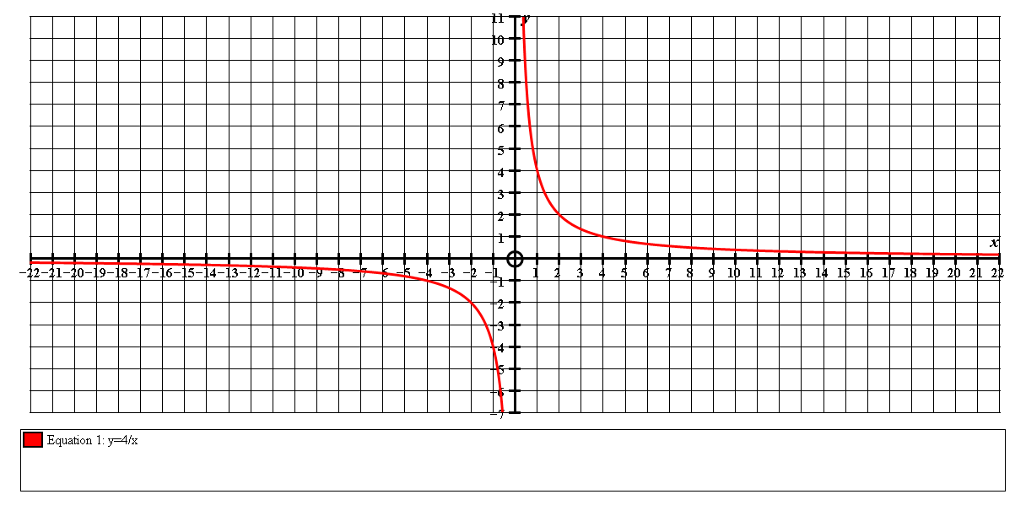

Equ will be of the form : ***y = b or xy = b***

***x***

Choose a point such as (2, 2) or (4, 1) to find ***b***

***y = 4***

***x***

13.

***y = – 2***

***x***

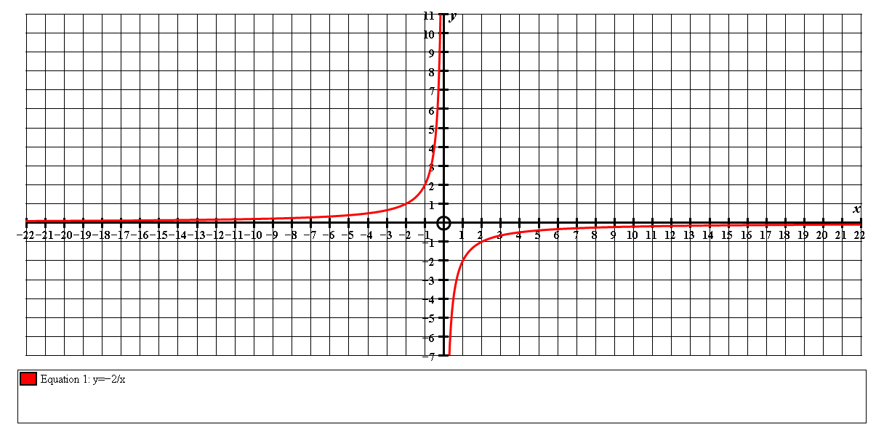

14.

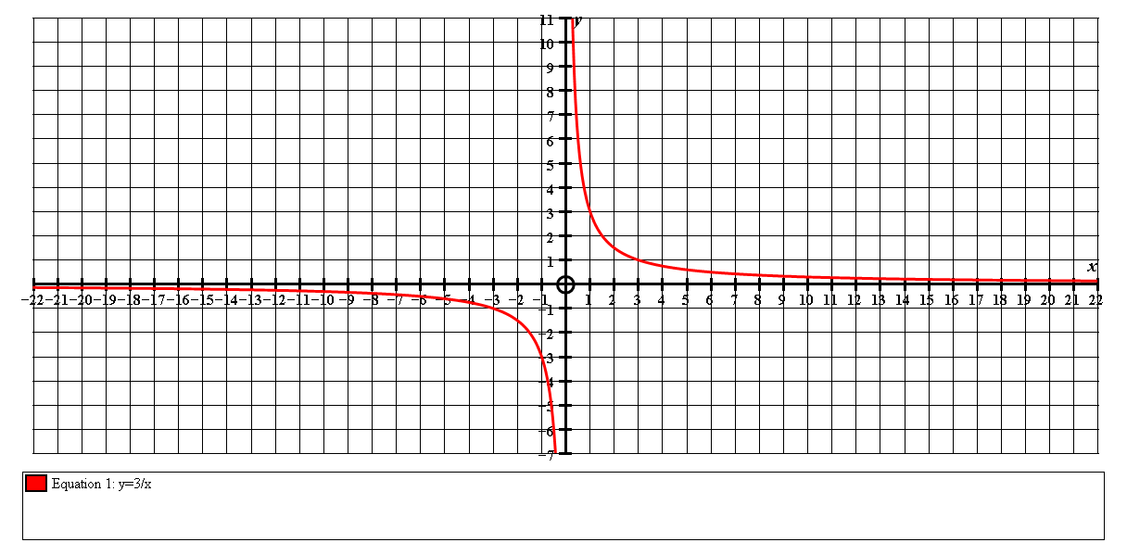

***y = 3***

***x***

15.

Equ will be of the form : ***y = b x and such graphs go through (0, 1)***

Look for a point such as (1, 3) to find ***b***

***y = 3x***

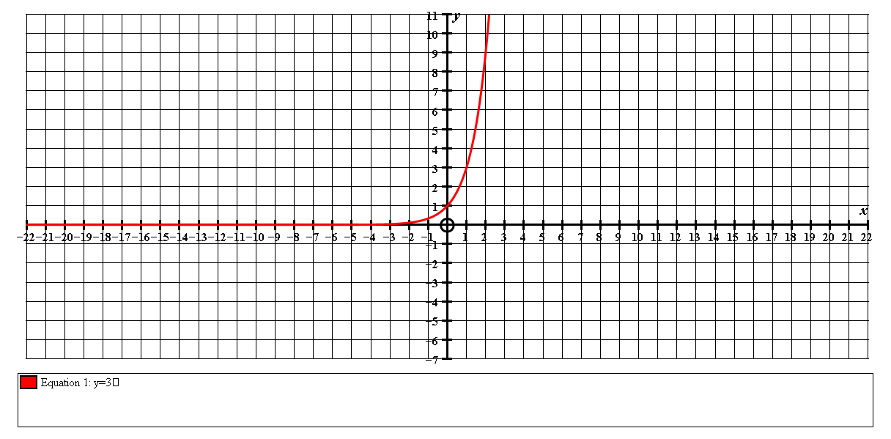

16.

This does not go through (0, 1) so the equation is of the form y = ***a*** × ***b x***

Subs ***x = 0, y = 3*** to find ***a***  and then look for a point such as (1, 6) to find ***b***

***y =3×2x***

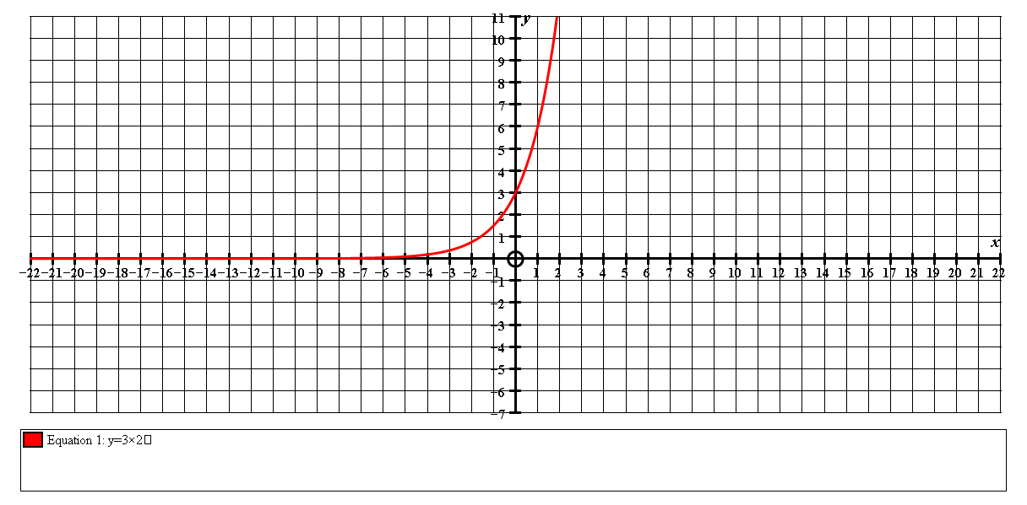

17.

This “growth” or exponential curve does not approach zero so its equ must be of the form: ***y = bx + c***  clearly c = 1

Find a suitable point for substitution such as (1, 3) or (2, 5) to find ***b***

***y = 2x + 1***

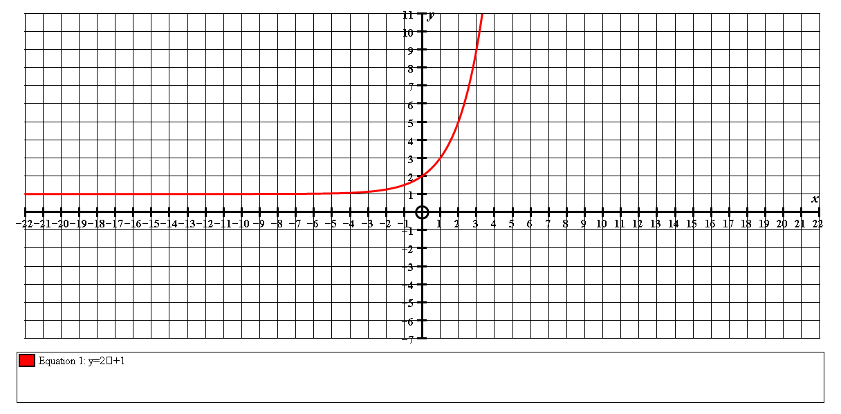

18.

Equ must be of the form: ***y = bx*** – ***c***  clearly ***y = bx – 2***

Find a suitable point to subs and find ***b***

***y = 3x – 2***

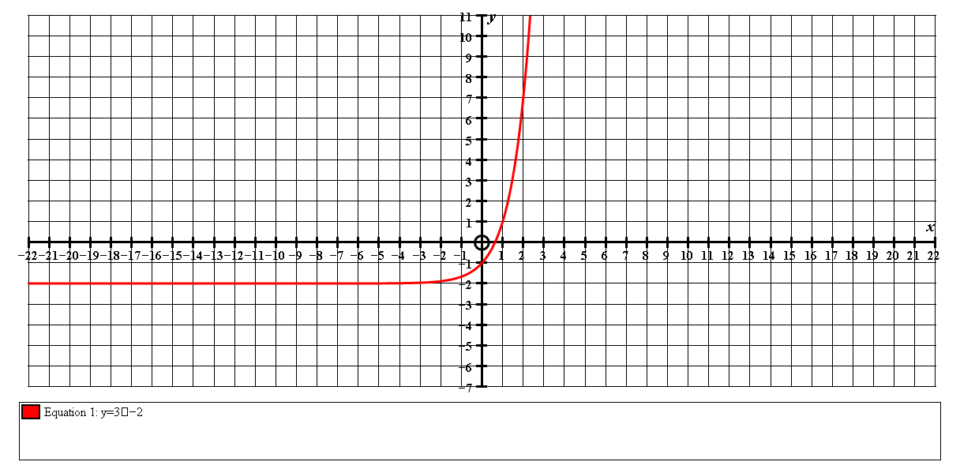

19.

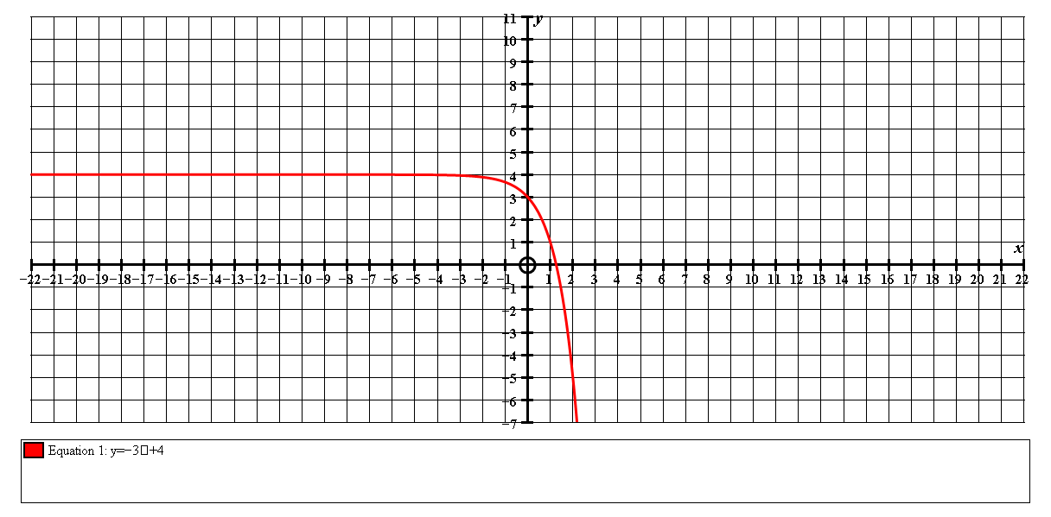

Equ must be of the form: ***y =*** –***bx + c***

***y = - 3x + 4***

20.

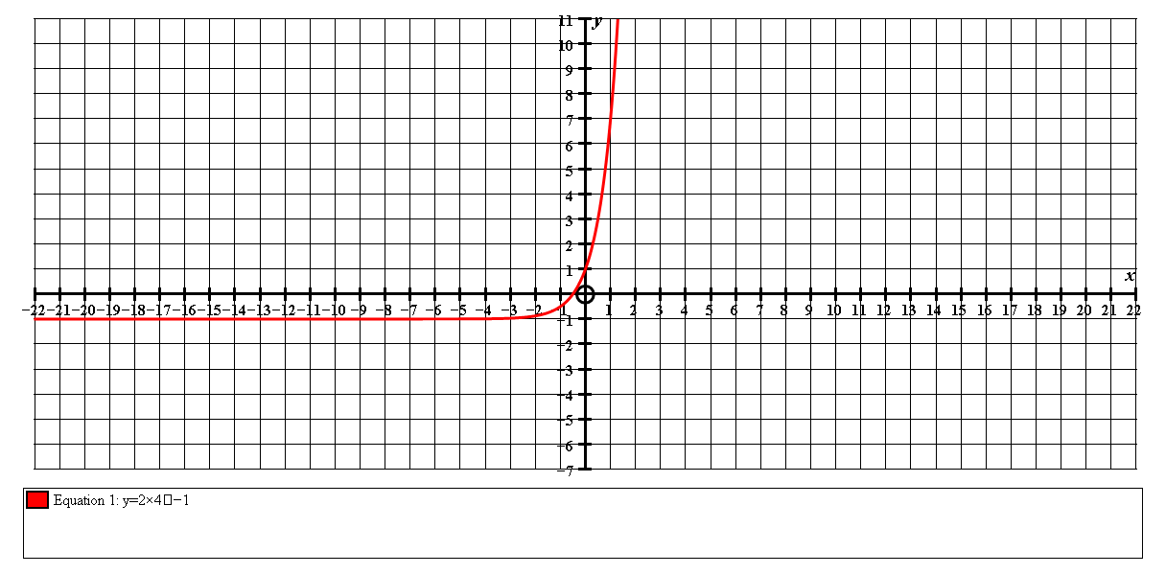

Find the equ in the form ***y = a×bx – c***

use the coordinates ( 0, 1) and (1, 7)

***y =2×4x – 1***