STEP GRAPHS (teacher notes)
Suppose the cost of a taxi consists of a flat fee of $3 followed by a $1 fee for every km travelled.
x = Number of km | y = Cost
0 | 3
1 | 4
2 | 5
3 | 6
We would probably expect that this graph shows this information:
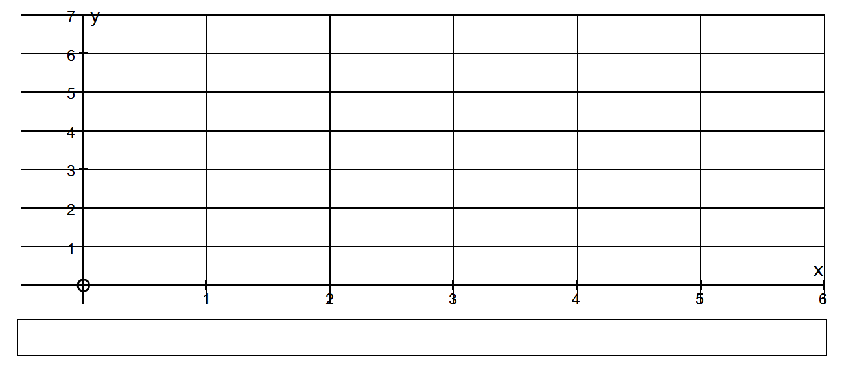
But the cost does not increase smoothly with a gradient of 1.
The cost of a ride up to but not including 1 km = $3
The cost SUDDENLY jumps to $4 at 1 km and stays there until the 2 km mark is reached.
The general convention is that a FULL CIRCLE includes the point and
an OPEN CIRCLE excludes the point.
At x = 2.9 km the cost is y = $5
At x = 3.0 km the cost is y = $6
At x = 3.1 km the cost is y = $6
This is called a STEP FUNCTION or STEP GRAPH and most costs must follow this idea.

Describe this step function using equations and domains.
SOLUTION
y = 3 if 0 ≤ x < 1
y = 4 if 1 ≤ x < 2
y = 5 if 2 ≤ x < 3
y = 6 if 3 ≤ x < 4

