THREE INVESTIGATIONS.
1(a) Find the coordinates of the points where the line y = ½x crosses the
circle given by (x – 4)² + y² = 8

(b)

A line of the form y = mx can cross the circle (x – 4)² + y² = 8
once or twice or not at all.
Find the value of m so that the line is a tangent.

2(a)
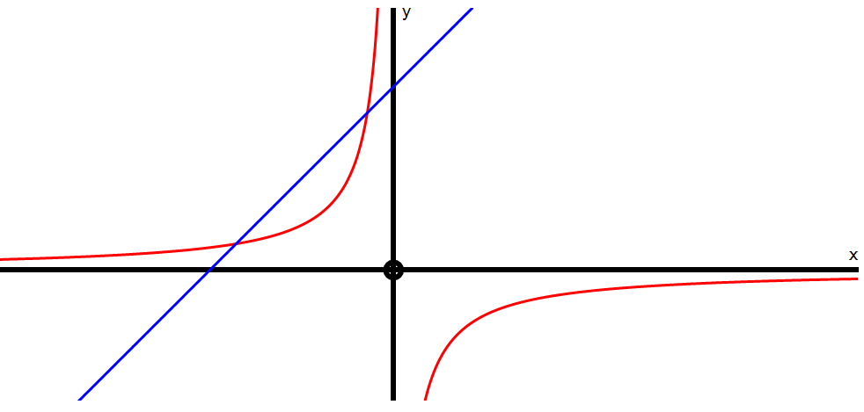

The graphs above show the intersection points of y = – 6 and y= x + 5
x
Find the coordinates of the intersection points algebraically.

(b) Consider the line y = mx + 5 which has a fixed y intercept at P but a
variable gradient m.
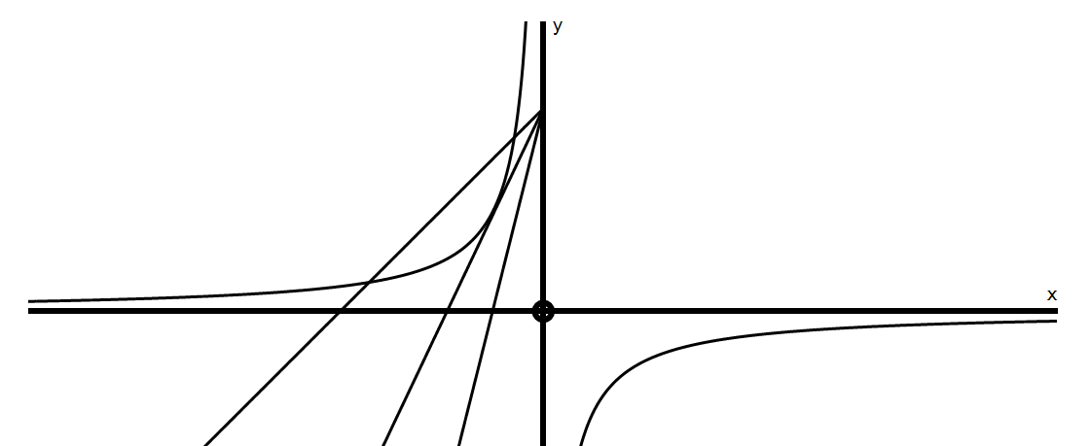
P
A B C
Line A crosses the hyperbola twice, Line B is a tangent and Line C does not cross.
Find the value of m so that y = mx + 5 is a tangent.

(c) Write down the range of values for m so that there will be 2 intersections.

(d) Write down the range of values for m so that there will be no intersections.

3(a) The graphs below show y = (x – 3)² and y = x – 3
Calculate algebraically the intersection points.

(b) Consider the line y = mx – 7 which has a fixed y intercept but a variable
gradient m.
Find the value of m so that
y = mx – 7 is a tangent to the parabola y = (x – 3)²

P

(c) If y = mx – k is to be a tangent to y = (x – k)² show that m² + 4km – 4k = 0

