Towards Excellence.
1.
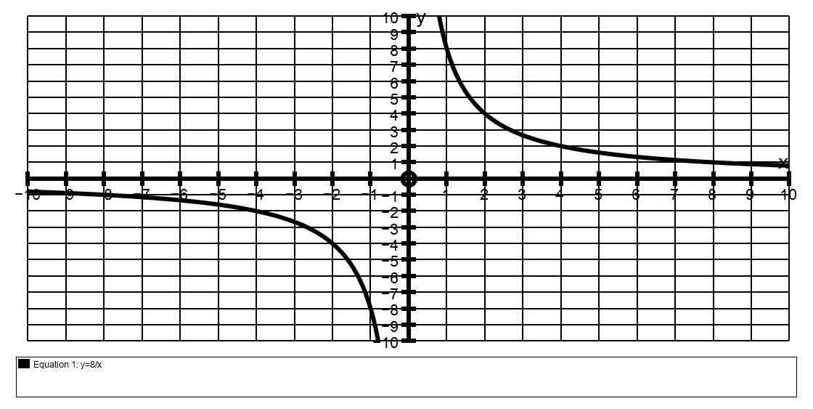
(a) Find algebraically, the intersection points of the graphs y = 8 and y = -x + 6
x

(b)(i) If y = -x + c is to be a tangent to y = 8 find c
x

(ii) Explain fully why there are two values for c.

(c) Find all the values of c for which the line y = -x + c will cross the
Hyperbola y = 8 at exactly two points.
x

(d) Find all the values of c for which the line y = -x + c will NOT cross the
Hyperbola y = 8 at all.
x

2. The graph shown has the equation y = 6 + 6
x
If a line y = mx is to be a tangent to y = 6 + 6 find m.
x
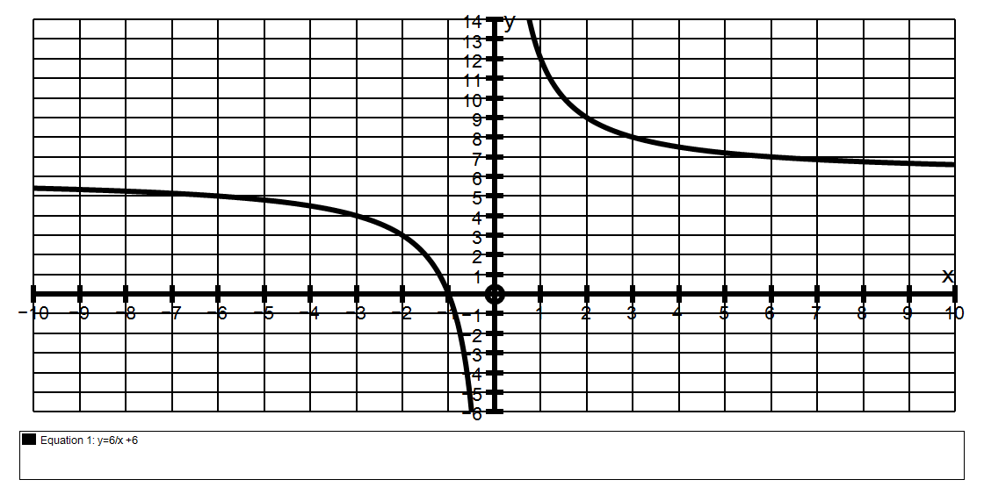

3. The graph below has the equation y = -12 + 9
x
If a tangent has a gradient of 2, find the coordinates of the point where the tangent meets the x axis.
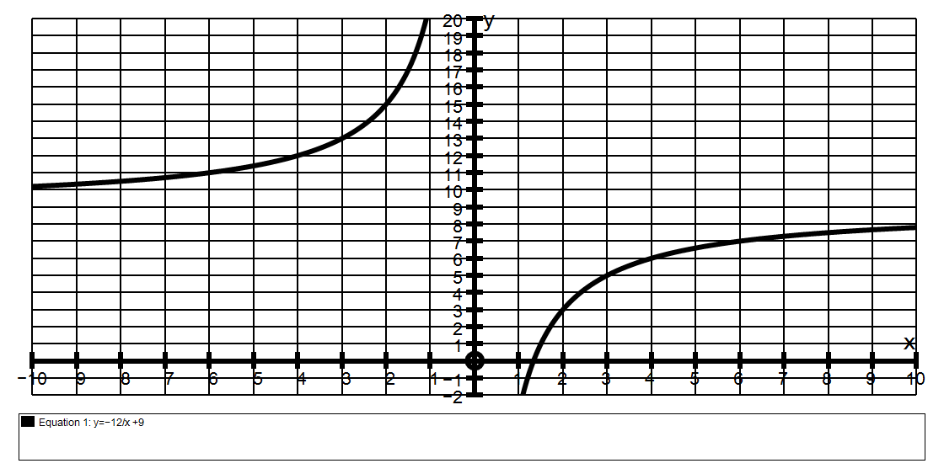
Explain clearly why there are TWO answers!

