The Waihopai Spy Base.

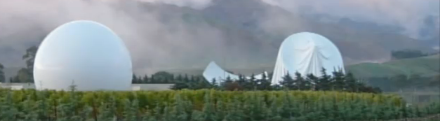
Three men entered a top secret defence communications base and damaged the spherical cover of a satellite dish in protest at the US “war on terror”.
Your mission, should you choose to accept it, is to destroy the other cover as shown above on the left.
You are to fire a high powered rifle from point A on the plan below.

The equation of the trajectory of your bullet is to be the line y = - 1 x + 20
3 3
(The path of the bullet is actually a parabola but with the high velocity bullet, the path is very close to a straight line until it has travelled well past the satellite cover.)

The equation describing the cover is x² + (y – 5) ² = 25 since the radius of the circular outline is 5 metres.
y

C
B
A x

By solving the equations x² + (y – 5)² = 25 and y = - 1 x + 20 simultaneously, find the
3 3
coordinates of the point B, (the point of entry of the bullet), and point C, (the point of exit of the bullet).

SOLUTION:

Substitute y = - 1 x + 20 into x² + (y – 5)² = 25
3 3
Obtaining: x² + ( -x + 20 – 15 )² = 25
3 3 3

x² + ( -x + 5 )² = 25
9

9x² + x² – 10x + 25 = 225

10x² – 10x – 200 = 0

10(x² – x – 20) = 0

10(x – 5)(x + 4) = 0

So x = 5 and – 4

B is the point (5, 5) and C is the point ( – 4, 8)

ALTERNATIVE QUESTION:

The path of the bullet is y = - x + 60
7

Substitute y = - x + 60 into x² + (y – 5)² = 25
7
Obtaining: x² + ( -x + 60 – 35 )² = 25
7 7 7

x² + ( -x + 25 )² = 25
49

49x² + x² – 50x + 625 = 1225

50x² – 50x – 600 = 0

50(x² – x – 12) = 0

50(x – 4)(x + 3) = 0

So x = 4 and – 3

B is the point (4, 8) and C is the point ( – 3, 9)

