COSINE GRAPHS.
1. The graph shown is y = cos(x)
On the axes below, draw the graphs:
(a) y = 2cos(x)
(b) y = 2cos(x) + 5

2. The graph shown is y = cos(x)
On the axes below, draw the graphs:
(a) y = 3cos(x)
(b) y = 3cos(x) + 4

3. What would the maximum and minimum y values be for the graph of
y = 9cos(x) + 3
MAX = MIN =

4. Find an equation in the form y = A + Bcos(x) so that the
maximum value is 14 and the minimum value is 6.
COSINE GRAPHS.ANSWERS
1. The graph shown is y = cos(x)
On the axes below, draw the graphs:
(a) y = 2cos(x)
(b) y = 2cos(x) + 5

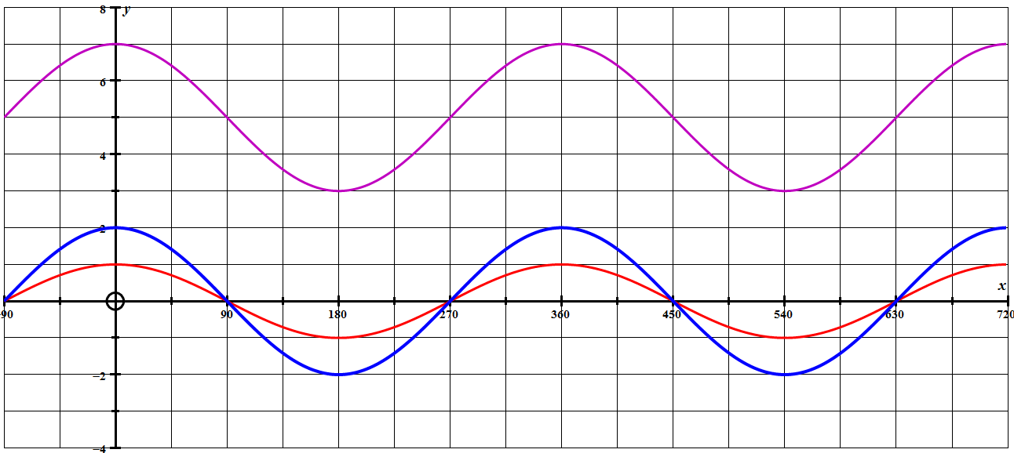

2. The graph shown is y = cos(x)
On the axes below, draw the graphs:
(a) y = 3cos(x)
(b) y = 3cos(x) + 4
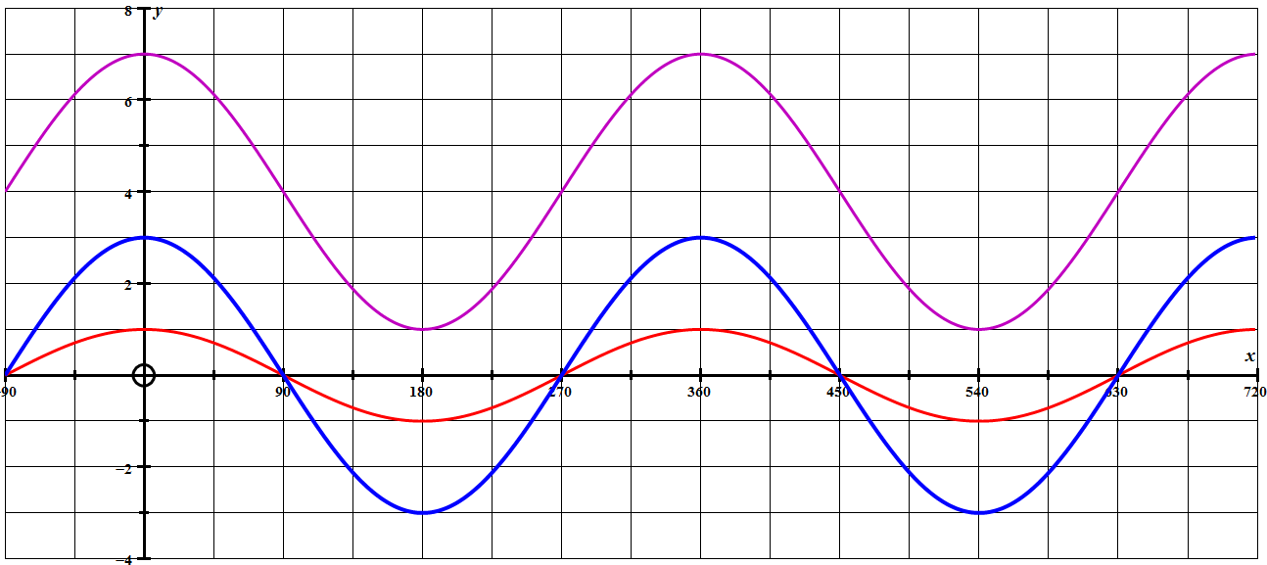

3. What would the maximum and minimum y values be for the graph of
y = 9cos(x) + 3
MAX = 12 MIN = 6

4. Find an equation in the form y = A + Bcos(x) so that the
maximum value is 14 and the minimum value is 6.
y = 4cos(x) + 10

