SINE GRAPHS.
1. The graph shown is y = sin(x)
On the axes below, draw the graphs:
(a) y = 2sin(x)
(b) y = 2sin(x) + 4

2. The graph shown is y = sin(x)
On the axes below, draw the graphs:
(a) y = 3sin(x)
(b) y = 3sin(x) + 5

3. What would the maximum and minimum y values be for the graph of
y = 8sin(x) + 7
MAX = MIN =
4. Find an equation in the form y = A + Bsin(x) so that the maximum value is 12
and the minimum value is 2

SINE GRAPHS.ANSWERS
1. The graph shown is y = sin(x)
On the axes below, draw the graphs:
(a) y = 2sin(x)
(b) y = 2sin(x) + 4

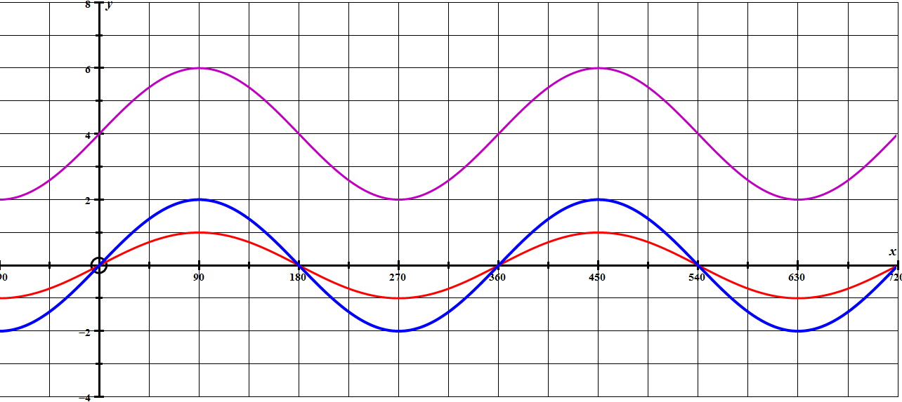

2. The graph shown is y = sin(x)
On the axes below, draw the graphs:
(a) y = 3sin(x)
(b) y = 3sin(x) + 5

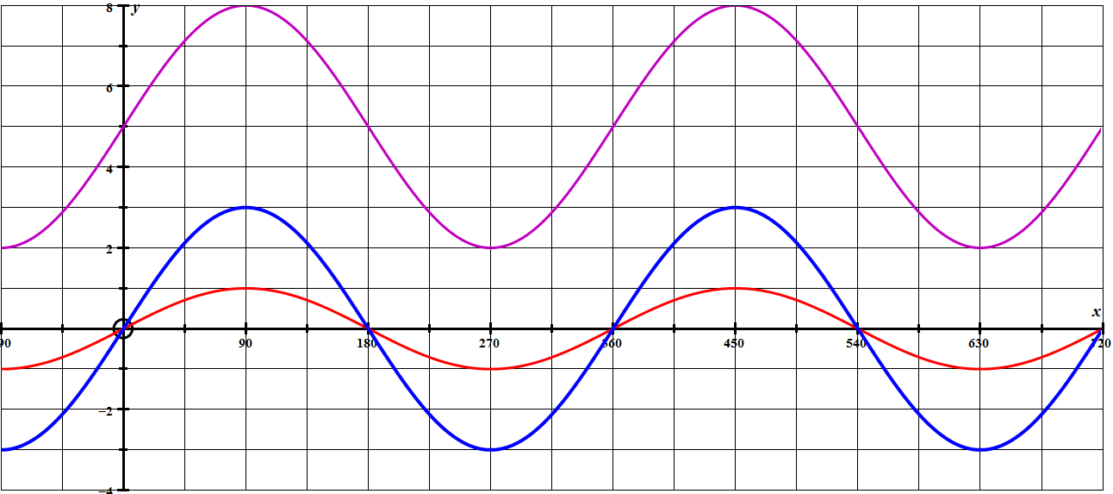

3. What would the maximum and minimum y values be for the graph of
y = 8sin(x) + 7
MAX = 15 MIN = 1
4. Find an equation in the form y = A + Bsin(x) so that the maximum value is 12
and the minimum value is 2 y = 7 + 5sin(x)

