SUMMARY OF GRAPH TECHNIQUES.
1.(a) Write down the information requested about the graph of
the function as shown below:

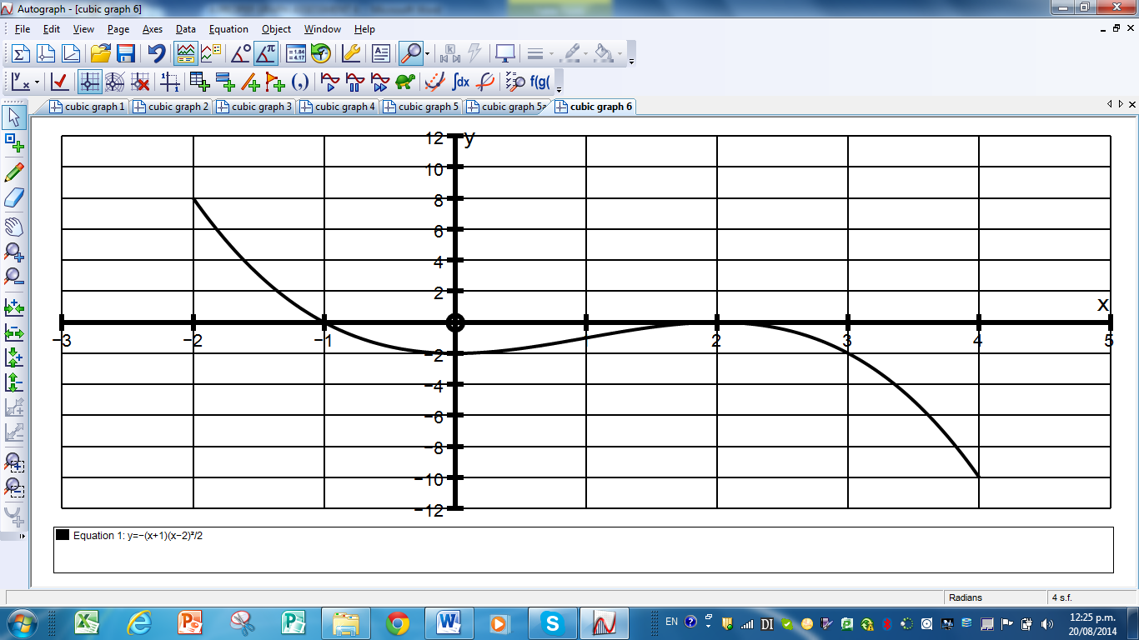
Among the features you should identify are:

(i) The general name of the type of graph shown.

(ii) The coordinates of the relative (local) minimum point.

(iii) The coordinates of the relative (local) maximum point.

(iv) The coordinates of the points where the graph crosses the x axis.

(v) The coordinates of the point where the graph crosses the y axis.

(vi) The domain of the function.

(vii) The range of the function.

(viii) The equation of the function.

(b)(i) Sketch the quartic function with x intercepts at
x = -1, 1, 3 and 4 and one y intercept at y = -4 on the grid below.

(ii) Write the equation of the quartic function.

(c) If the function below is y = f(x) draw the transformed function
y = f(x – 4) + 5 on the same grid.

(d) Give the domain and range of the translated function.

2. A student is trying to decide what the differences are between a
hyperbola and a log function.
The teacher tells the student to look out for special points on the graphs.
The hyperbola is of the form y = b and if we write it as xy = b we can
x
see that any x and y values will multiply to give the same number b.
The basic log graph always goes through (1, 0) and if it goes through (2, 1)
it is y = log ₂ (x) . If it goes through ( 5, 1) it is y = log ₅ (x)
The only difficulty is if the log graph is translated. For example suppose it
goes through ( 4, 0) and (5, 1) then it must have been translated 4 units to
the right producing y = log₂(x – 4).
Find the equations of these graphs:
E
A
D
C
B

A

B

C

D

E

3. A jetty at the beach is a good place for Billy to swim but at certain times it is too deep for him.
The depth D, of the water can be modelled using the equation
D = 120 + 50cos(30t) where D is the depth in centimetres and t is the number of hours after high tide which is at 12 o’clock midday.
(a) Draw a careful graph of the tide cycle from 3 hours before the mid-day
high tide to 3 hours after the next high tide at mid-night. (ie t = - 4 to t = 16 )
D centimetres
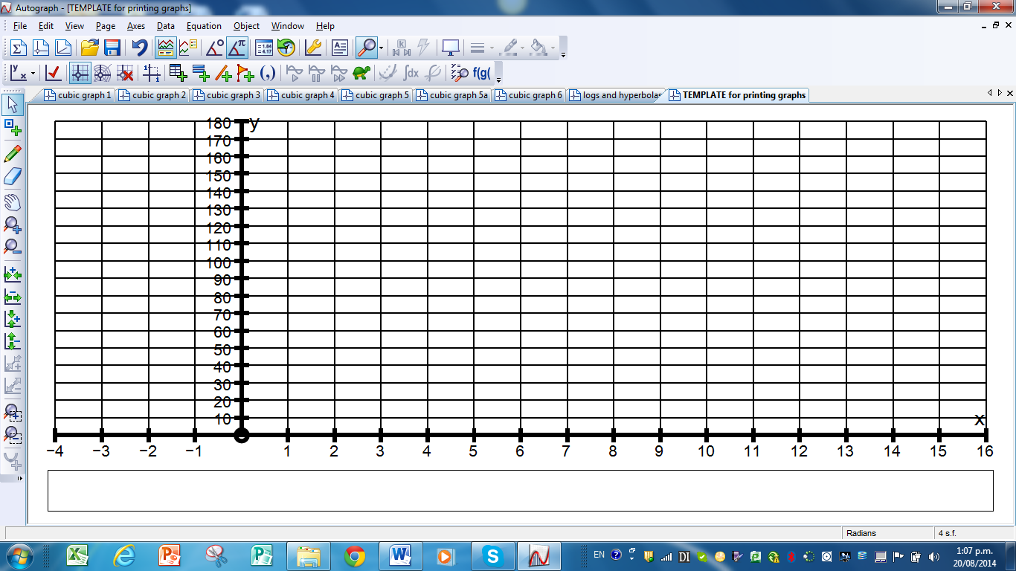
t hours
12
Mid –
night
12
noon

Billy does not want to swim if the depth is over 150 cm

(b) Use the graph to find the times between which Billy could swim between
12 noon and 12 midnight.

(c) The above model is based on the time between high tides being 12 hours.
If the actual time between high tides is 12 hours 25 minutes find a more
accurate model formula for the above location.

5. The line below is in a fixed position and it passes through some whole number points such as (4, 3), (8, 4), (12, 5), (16, 6) etc
A parabola is drawn through the fixed point (0, 2) and (4, 3)

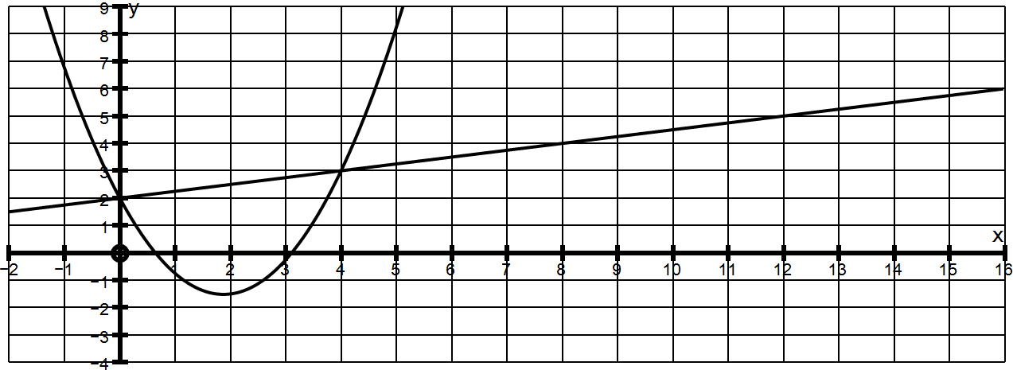
(a) Find the equation of the above parabola in the form y = x² – bx + 2

(b) Find the equation of the next parabola in the sequence which goes through
(0, 2) and (8, 4)

(c) Find the equation of the next parabola in the sequence which goes through
(0, 2) and (12, 5)

(d) The pattern for x values is 4n and the pattern for y values is n + 2
If n = 1 this produces the point (4, 3)
If n = 2 this produces the point (8, 4)
If n = 3 this produces the point (12, 5)
etc
Find a general equation for the value of b in this sequence and find the
general equation of parabolas passing through (0, 2) and any whole number
point on the line graph.

